ELECTRIC DRIVELINE SYSTEM SPECIALIST

CASE STUDY REPORT:

Title of the report

Author:

Abdul-basit raheem.

**October 23, 2024**

CONTENTS

1 Introduction 3

2 Traction Motor Sizing Procedure 3

2.1 Variables 3

2.2 Driving Cycle 3

2.3 Vehicle Model 3

2.4 Requirements at the Wheels 3

2.4.1 Peak Power Demand at the Wheels 3

2.4.2 Continuous Power Demand at the Wheels 3

2.5 Gear box 3

2.6 Requirement at the Motor Shaft 3

2.6.1 Peak Power Demand at the Shaft 3

2.6.2 Continuous Power Demand at the Shaft 3

2.6.3 Critical Drivetrain Speeds at the Shaft 3

2.7 Required values at the e-machine shaft 3

3 Conclusion 3

# Introduction

The automotive industry is undergoing a major shift in product development due to increasing government regulations promoting electric and hybrid vehicle production. Key components like the traction battery, inverter, and electric machine are now crucial for vehicle cost and layout. While the battery is modular and the inverter compact, the electric machine, integrated with the transmission, tends to take up significant space. To minimize the drivetrain size, the electric machine must be made smaller without compromising efficiency and power density.

Electric vehicles (EVs) have a wide range of operating points depending on the driving profile. A driving cycle, which standardizes speed over time, helps in sizing the drivetrain. Manufacturers can seize the system using empirical methods or full optimization. Empirical methods are fast but often lead to oversizing, while full optimization, though more efficient, is complex and may be beyond the manufacturer’s scope, as key components like the electric machine are supplied by external vendors.

This paper proposes a combined approach using vehicle dynamics, driving cycles, and empirical data for peak and continuous performance calculations. This methodology provides a balanced solution that can be used for further electric machine design

# Traction Motor Sizing Procedure

The sizing of traction motors is a critical process in the design and development of electric and hybrid vehicles. It involves determining the appropriate size and power output of the electric motor needed to meet the vehicle’s performance requirements under various driving conditions. An effective sizing procedure ensures optimal performance, efficiency, and cost-effectiveness. Below is a comprehensive outline of the traction motor sizing procedure:

## Variables

Several factors affect traction motor sizing and must be carefully analyzed:

* **Vehicle Mass (m):** The vehicle's weight influences the forces needed for acceleration and deceleration.
* **Rolling Resistance (Cr):** Dependent on tire type and road conditions.
* **Aerodynamic Drag (Cd):** A function of speed and vehicle shape.
* **Frontal Area (A):** Contributes to drag forces.
* **Gradeability (G):** Road slope affects torque demand on inclines.

The traction force is calculated as:

*Ftraction=Fa+Fr+Fg+ms⋅dvdtF_{traction} = F_a + F_r + F_g + m_s \cdot \frac{dv}{dt}*Ftraction =Fa +Fr +Fg +ms ⋅dtdv

These factors determine the power and torque required for efficient performance in both urban and highway settings.

|  |  |  |  |  |
| --- | --- | --- | --- | --- |
| **Variable name** | **Symbol** | **Value** | **Unit** |  |
| Vehicle velocity | vt | Driving cycle | m/s |  |
| Vehicle acceleration | dvt/dt | Driving cycle | m/s2 |  |
| Road gradient | α | Driving cycle | % |  |
| Vehicle mass | ms | 2400,00 | kg |  |
| Air density | ρa | 1,25 | kg/m3 |  |
| Vehicle front cross section | A | 4,00 | m2 |  |
| Air drag coefficient | cd | 0,35 | - |  |
| Rolling resistance coefficient | cr | 0,007 | - |  |
| Gravity acceleration | g | 9,81 | m/s2 |  |
| Wheel diameter | dWH | 0,73 | m |  |
| Low speed gearbox losses | P0 | 200,00 | W |  |
| Gearbox losses cutoff speed | ωc | 20,00 | rad/s |  |
| Transfer ratio | i | 9,40 | - |  |
| Gearbox efficiency | ηGB | 0,97 | - |  |
| Number of traction units (GB + EM) | NDU | 2,00 | - |  |
|  |  |  |  |  |

## Driving Cycle

A driving cycle is a data set describing vehicle speed (and optionally road gradient) over time and is a key input in drivetrain design. It can be defined by the manufacturer or standardized by authorities (e.g., EUDC, NEDC, FTP75). Standard cycles are used for emissions analysis, while non-standard cycles apply to special vehicles like supercars. OEMs can log real-world driving data to design future vehicles.

Multiple driving cycles may be used during design to adapt vehicles to different markets. In this paper, a single driving cycle with a zero-road gradient is used to calculate power and torque demands at the wheels.

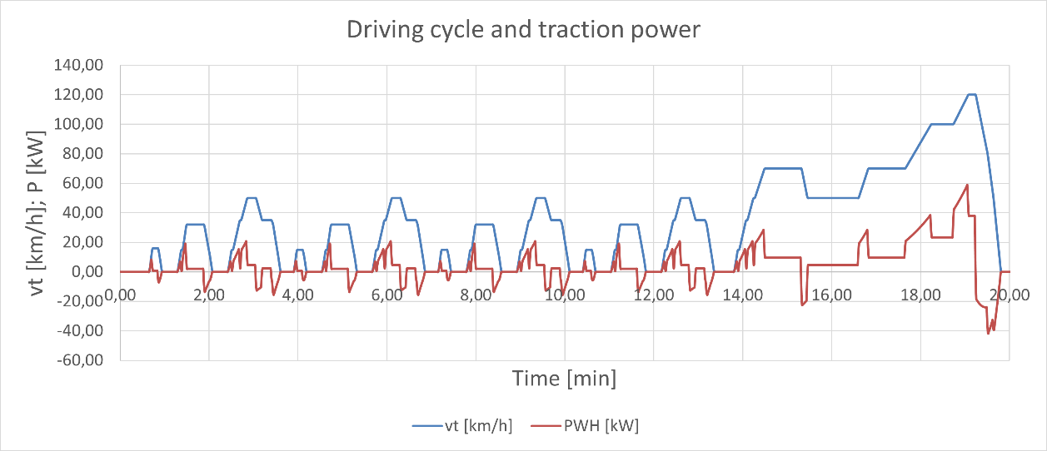

The figure shows speed and power over time during the New European Driving Cycle (NEDC), which alternates between urban and highway conditions.

**Analysis:** In urban driving, frequent speed changes cause power peaks during acceleration and drops during deceleration. In highway driving, speed stabilizes, and power demand remains steady at a lower level, as maintaining speed requires less power than acceleration.

This figure highlights the contrast between peak power (during acceleration) and continuous power (during steady driving), emphasizing the need for the motor to efficiently handle varying conditions.

## Vehicle Model

A Vehicle Model is a detailed mathematical representation of a vehicle that is used to simulate its dynamic behavior and performance under various driving conditions. It is crucial to modern vehicle development, as it makes it possible to analyze and optimize vehicle characteristics such as acceleration, braking, energy consumption, driving stability and handling. Using a vehicle model, engineers and researchers can test and predict how a vehicle will react in different driving scenarios and environments, reducing the need for extensive and expensive physical prototypes and tests.

## Requirements at the Wheels

Understanding the requirements at the wheels of a vehicle is crucial for designing an efficient and effective drivetrain, particularly for electric and hybrid vehicles. The wheel requirements encompass a range of performance metrics that are essential for achieving the desired vehicle dynamics, stability, and efficiency.

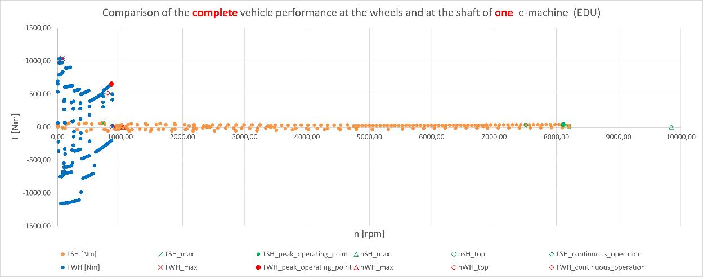

The figure shows the relationship between vehicle speed and power at the wheels.

**Analysis:** Power demand increases with speed, peaking at higher speeds, especially during rapid acceleration or hill climbs. This peak power is key for sizing the traction motor as it represents the motor's maximum required output. At constant speeds, particularly on highways, power demand levels off, indicating the need for the motor to efficiently provide continuous power over extended periods without overheating.

### Peak Power Demand at the Wheels

Understanding the peak power demand at the wheels of a vehicle is critical for designing an efficient drivetrain, especially in electric and hybrid vehicles. Peak power demand refers to the maximum amount of power required at the wheels during specific driving conditions, such as rapid acceleration, climbing steep grades, or navigating challenging terrains. Accurately assessing this demand helps engineers ensure that the vehicle's powertrain can deliver the necessary performance without compromising efficiency or reliability

## Continuous Power Demand at the Wheels

Continuous power demand at the wheels of a vehicle refers to the steady-state power requirement needed to maintain a specific speed or performance level over an extended period. This metric is essential for understanding how a vehicle operates during regular driving conditions, as opposed to peak power demand, which is often experienced during rapid acceleration or sudden maneuvers. Assessing continuous power demand helps engineers design and optimize vehicle components, ensuring that the drivetrain operates efficiently and effectively under normal driving conditions.

## Gear box

A gearbox, also known as a transmission, is a crucial component in a vehicle’s drivetrain. It is responsible for transmitting power from the engine or electric motor to the wheels while enabling the vehicle to operate efficiently at varying speeds and loads. The design and functionality of a gearbox significantly influences a vehicle's performance, fuel efficiency, and overall driving experience.

## Requirement at the Motor Shaft

The motor shaft is a critical component in electric and hybrid vehicles, serving as the connection between the electric motor and the drivetrain. Understanding the requirements at the motor shaft is essential for optimizing vehicle performance, efficiency, and reliability. The motor shaft transmits power from the electric motor to the wheels, and its design must accommodate various operational demands to ensure effective vehicle dynamics.

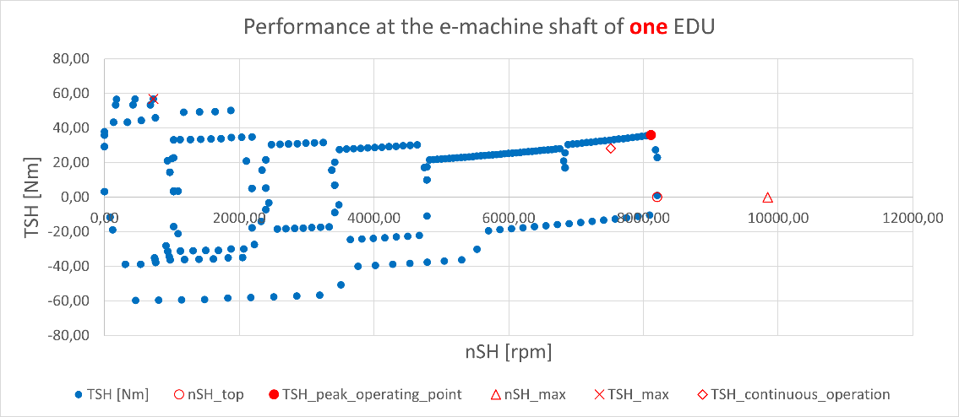

The figure shows the motor's torque-speed performance.

**Analysis:** At low speeds, the motor operates in the constant torque region, delivering high torque for acceleration, ideal for urban driving. As speed increases, the motor enters the constant power region, where torque decreases but power stays constant, crucial for maintaining high speeds on highways. This highlights the motor's ability to provide strong acceleration and handle steep gradients while ensuring efficient performance at higher speeds.

## Peak Power Demand at the Shaft

The peak power demand at the shaft of an electric or hybrid vehicle is a critical consideration in drivetrain design and vehicle performance analysis. Understanding this demand allows engineers to ensure that the electric motor, drivetrain components, and associated systems can handle the maximum power requirements during various driving conditions.

## Continuous Power Demand at the Shaft

The continuous power demand at the shaft of an electric or hybrid vehicle is a crucial metric that reflects the average power requirement over a sustained period of operation. Unlike peak power demand, which considers short bursts of high power needed for acceleration or overcoming obstacles, continuous power demand represents the power necessary to maintain steady-state conditions during regular driving.

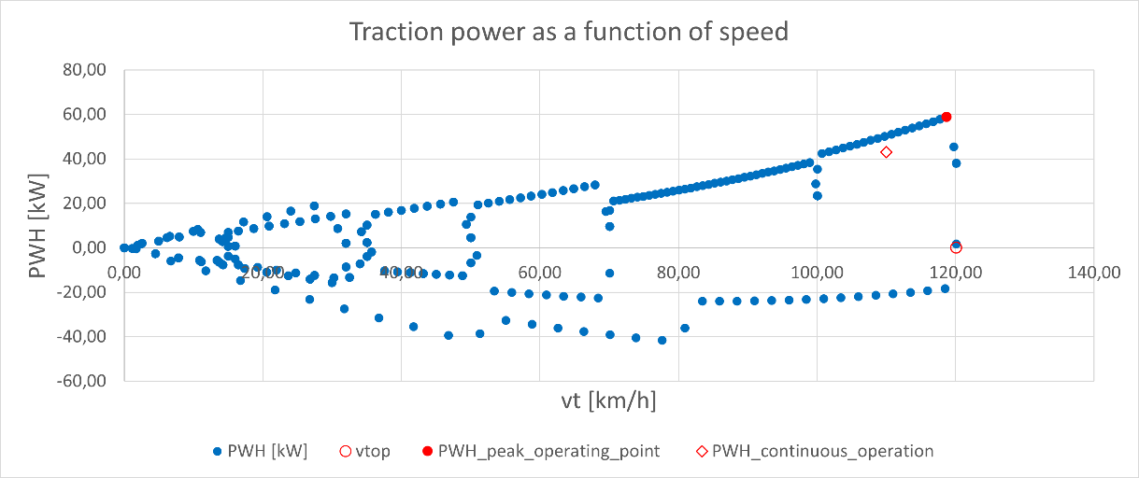

The figure shows traction power required at different vehicle speeds.

**Analysis:** As the vehicle accelerates, traction power increases. At lower speeds (city driving), power fluctuates with starts and stops, while at higher speeds (highway driving), power stabilizes, reflecting continuous needs.This highlights the importance of a traction motor that can handle both peak power for acceleration and continuous power for steady driving efficiently.

## Critical Drivetrain Speeds at the Shaft

Understanding the critical drivetrain speeds at the shaft of an electric or hybrid vehicle is essential for optimizing performance, efficiency, and reliability. These critical speeds determine the operational limits of the drivetrain components and directly influence the vehicle's overall dynamics, including acceleration, braking, and handling.

## Required values at the e-machine shaft

When designing electric or hybrid vehicles, it’s crucial to define the required values at the electric machine (e-machine) shaft. These values are fundamental for ensuring optimal performance, efficiency, and reliability of the electric drive system.

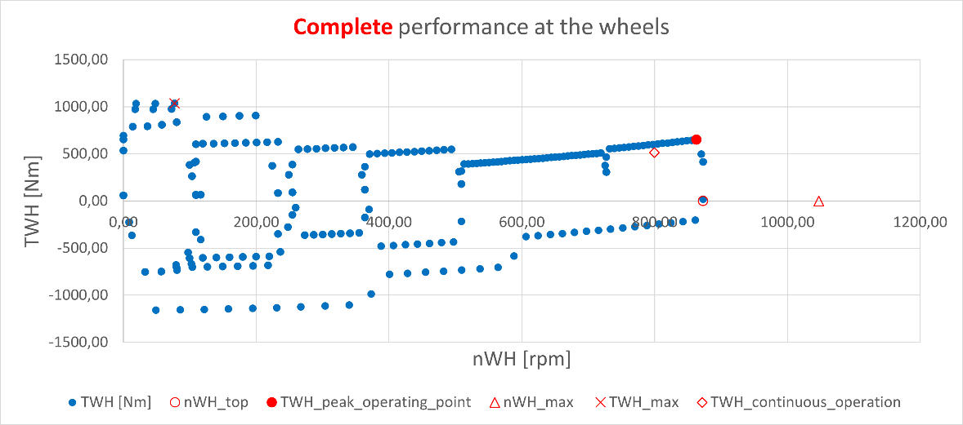The figure shows motor efficiency across different speeds.

**Analysis:** Motor efficiency is typically highest in the mid-speed range, where power losses are minimized. At low speeds, efficiency drops due to resistive losses, and at high speeds, it decreases because of windage and drivetrain friction.

This curve is key to understanding how motor efficiency impacts vehicle range and performance in various driving conditions.

# Conclusion

The summarizes the essential inputs for sizing electric vehicle drivetrains, emphasizing the role of the driving cycle, vehicle dynamics, and transmission models in determining traction performance requirements. It discusses various peak and continuous performance criteria for different vehicle types, presenting a case study that uses driving cycle data for peak performance and empirical data for continuous performance. Calculations were performed at the vehicle level and then adjusted for the electric machine shaft, accounting for transmission losses. The case study features a drivetrain with fixed gear ratios in both front and rear units, utilizing identical traction machines, simplifying calculations. Overall, this paper serves as a foundational reference model for sizing electric and hybrid drivetrains, with the next step focusing on designing an electric machine to meet the specified performance requirements.